Cranberry Bliss Bars
(Starbucks copycat recipe)

Ingredients

Bars:
1 cup (2 sticks) butter, melted
1 ½ cups packed brown sugar
2 eggs
1 tsp orange extract
1 tsp vanilla extract
½ tsp ground ginger
1 tsp baking powder
½ tsp salt
2 cups all-purpose flour
1 cup white chocolate chips
¾ cup Craisins

Frosting and Topping:
(Use Best Cream Cheese Frosting – separate recipe)

1/3 cup Craisins, roughly chopped
2 squares baking chocolate or almond bark, melted

Instructions:

- Preheat oven to 350°F. Line a 15x10-inch jelly roll pan (rimmed cookie sheet) with parchment paper.
- Beat together melted butter and brown sugar over medium speed with an electric mixer. Add in eggs, 1 tsp orange extract, and 1 tsp vanilla extract. Beat until mixed well. Add in ground ginger, baking powder, salt, and flour, beating until just blended. Do not overmix.
- Stir in white chocolate chips and Craisins by hand. Spread evenly into the bottom of prepared pan. Bake in preheated oven for 18-22 minutes (20 is perfect) until set and golden brown at the edges. Don’t overbake or bars will be hard. Remove from oven and place pan on a wire rack to cool. Allow bars to cool completely before topping with frosting.
- Top cooled bars with frosting.
- Sprinkle with chopped Craisins and drizzle while chocolate over the top with a fork. Dip the fork into melted chocolate; then, shake gently over the top of the bars to create little streaks.
- You can either slice right away and enjoy, or place the bars in the refrigerator for about an hour to help them set up before cutting. Cut into triangles and enjoy.

How to cut the bars. I cut one more time the other direction for even smaller triangles.
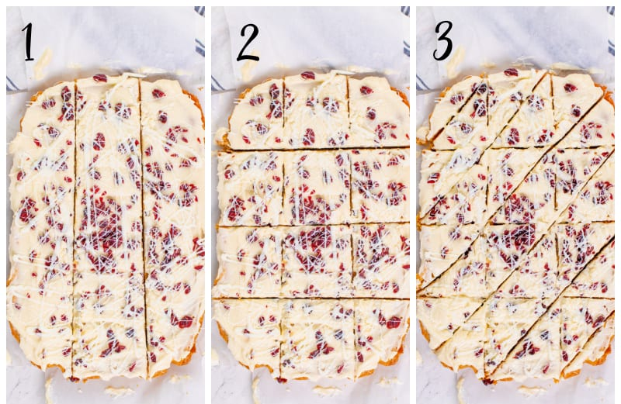
How to store: once the bars are sliced, place them in an airtight container and store in refrigerator up to five days.
How to freeze: prepare and slice as directed. Place the bars in the refrigerator for at least four hours, then cover tightly in a container with both plastic wrap and aluminum foil. Freeze the bars up to three months. Thaw the bars overnight in the refrigerator before serving.

Nutrition
Calories 289kcal | Carbohydrates: 39g | Protein: 14g | Saturated Fat: 8g | Cholesterol: 45 mg | Sodium: 163 mg | Potassium: 89mg | Sugar: 29mg | Vitamin A: 385IU | Calcium: 49mg | Iron: 0.8mg

Note: nutrition is slightly different due the difference in the frosting recipe used.

Website: https://belleofthekitchen.com/cranberry-bliss-bars-starbucks-copycat-recipe/

